**Table 1:** **Survey Site Information and Electrofishing Details**

|  |  |  |  |  |  |  |
| --- | --- | --- | --- | --- | --- | --- |
| **Watercourse** | **Site Code** | **Ordinance Survey Grid Reference** | **Easting** | **Northing** | **Date** | **Electrofishing Type** |
| Allt Deveron | A3 | NJ382226 | 338200 | 822600 | 07/07/2023 | Quantitative (1mm) |
| Back Burn | Ba0 | NJ372244 | 337298 | 824444 | 07/07/2023 | Timed |
| Back Burn | Ba1 | NJ380249 | 338055 | 824905 | 07/07/2023 | Timed |
| Black Water | BW0 | NJ327234 | 332753 | 823406 | 07/07/2023 | Quantitative (1mm) |
| Black Water | BW4 | NJ328260 | 332834 | 826029 | 06/07/2023 | Timed |
| Allt na Craoibhe-caorainn | Cn0 | NJ315253 | 331537 | 825331 | 06/07/2023 | Timed |
| Allt na Craoibhe-caorainn | Cn2 | NJ324258 | 332418 | 825846 | 07/07/2023 | Timed |
| Allt na Craoibhe-cuilinn | CU1 | NJ322245 | 332296 | 824569 | 06/07/2023 | Timed |
| Gauch Burn | GC0 | NJ354246 | 335419 | 824694 | 07/07/2023 | Timed |
| Gauch Burn | GC1 | NJ364248 | 336445 | 824808 | 06/07/2023 | Quantitative (1mm) |
| Gauch Burn | GC | NJ348249 | 334844 | 824939 | 06/07/2023 | Timed |
| Gauch Burn | GCa | NJ348249 | 334842 | 824958 | 07/07/2023 | Timed |
| Keirn Burn | Kei1 | NJ364247 | 336421 | 824724 | 07/07/2023 | Timed |
| Kindy Burn | KY2 | NJ393231 | 339318 | 823129 | 07/07/2023 | Timed |

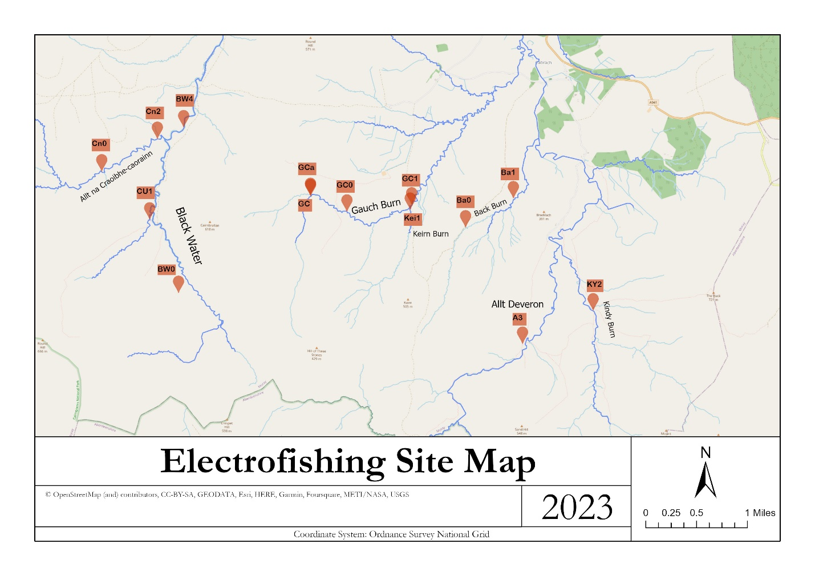

**Figure 1: Spatial Distribution of Survey Points and Site Codes along Water Courses**

**Table 2: Density (fish per 100m-2) of Juvenile Salmon and Trout Caught Using 3-pass Electrofishing at Each Survey Site**

|  |  |  |  |  |  |
| --- | --- | --- | --- | --- | --- |
| **Site** | **Salmon (100m-2** ) | | **Trout (100m-2** ) | | **Eels** |
| **0+** | **1+ - 3+** | **0+** | **1+ - 3+** | **Present / Absent** |
| A3 | 0.07 | 0.27 | 0.32 | 0.07 | Absent |
| BW0 | 0.03 | 0.12 | 0.08 | 0.16 | Absent |
| GC1 | 0.11 | 0.12 | 0.65 | 0.37 | Absent |

**Table 3: Juvenile Salmon and Trout Catch Rate per Minute Using Timed Electrofishing at Each Survey Site**

|  |  |  |  |  |  |
| --- | --- | --- | --- | --- | --- |
| **Site** | **Salmon (per minute**) | | **Trout (per minute**) | | **Eels** |
| **0+** | **1+ - 3+** | **0+** | **1+ - 3+** | **Total caught** |
| Ba0 | 0 | 0 | 11 | 10 | 0 |
| Ba1 | 0 | 4 | 10 | 12 | 0 |
| BW4 | 9 | 14 | 2 | 3 | 0 |
| Cn0 | 2 | 5 | 4 | 9 | 0 |
| Cn2 | 0 | 15 | 6 | 5 | 0 |
| CU1 | 0 | 1 | 22 | 17 | 0 |
| GC0 | 0 | 0 | 3 | 14 | 0 |
| GC | 0 | 0 | 21 | 11 | 0 |
| GCa | 0 | 0 | 18 | 10 | 0 |
| Kei1 | 0 | 5 | 6 | 9 | 0 |
| KY2 | 5 | 5 | 27 | 10 | 0 |

**Table 4: Summary of Habitat at Each Survey Site**

|  |  |
| --- | --- |
| **Survey Site** | **A3** |
| Altitude | 376m |
| Predominant Depth Range | N/A |
| Average Wet Width | 3.2m |
| Predominant Substrate | Cobble |
| Area Affected by Siltation | No |
| Canopy Cover (%) | 0 |
| Main Land Use | Moorland/heath and rough pasture |
| No of Pollution Points | 0 |
| No of Obstructions | 0 |
| Instream Cover | Moderate |
| Overall Description | N/A |

|  |  |
| --- | --- |
| **Survey Site** | **Ba0** |
| Altitude | 375m |
| Predominant Depth Range | 21-30m |
| Average Wet Width | 0.8 |
| Predominant Substrate | Pebble |
| Area Affected by Siltation | No |
| Canopy Cover (%) | 0 |
| Main Land Use | Moorland/heath |
| No of Pollution Points | 0 |
| No of Obstructions | 0 |
| Instream Cover | Moderate |
| Overall Description | N/A |

|  |  |
| --- | --- |
| **Survey Site** | **Ba1** |
| Altitude | 350m |
| Predominant Depth Range | 21-30m |
| Average Wet Width | 1.8 |
| Predominant Substrate | Pebble |
| Area Affected by Siltation | No |
| Canopy Cover (%) | 0 |
| Main Land Use | Rough pasture |
| No of Pollution Points | 0 |
| No of Obstructions | 0 |
| Instream Cover | Moderate |
| Overall Description | N/A |

|  |  |
| --- | --- |
| **Survey Site** | **BW0** |
| Altitude | 507m |
| Predominant Depth Range | 11-20m |
| Average Wet Width | 3.1m |
| Predominant Substrate | Cobble |
| Area Affected by Siltation | No |
| Canopy Cover (%) | 0 |
| Main Land Use | Moorland/heath |
| No of Pollution Points | 0 |
| No of Obstructions | 0 |
| Instream Cover | Good |
| Overall Description | N/A |

|  |  |
| --- | --- |
| **Survey Site** | **BW4** |
| Altitude | 413m |
| Predominant Depth Range | 11-20m |
| Average Wet Width | 4.0m |
| Predominant Substrate | Pebble and Cobble |
| Area Affected by Siltation | No |
| Canopy Cover (%) | 0 |
| Main Land Use | Moorland/heath |
| No of Pollution Points | 0 |
| No of Obstructions | 0 |
| Instream Cover | Good |
| Overall Description | N/A |

|  |  |
| --- | --- |
| **Survey Site** | **Cn0** |
| Altitude | 444m |
| Predominant Depth Range | 11-40m |
| Average Wet Width | 1.7m |
| Predominant Substrate | Cobble |
| Area Affected by Siltation | No |
| Canopy Cover (%) | 0 |
| Main Land Use | Moorland/heath |
| No of Pollution Points | 0 |
| No of Obstructions | 0 |
| Instream Cover | Good |
| Overall Description | N/A |

|  |  |
| --- | --- |
| **Survey Site** | **Cn2** |
| Altitude | 422m |
| Predominant Depth Range | 11-20m |
| Average Wet Width | 3.0 |
| Predominant Substrate | Cobble |
| Area Affected by Siltation | No |
| Canopy Cover (%) | 0 |
| Main Land Use | Moorland/heath |
| No of Pollution Points | 0 |
| No of Obstructions | 0 |
| Instream Cover | Good |
| Overall Description | N/A |

|  |  |
| --- | --- |
| **Survey Site** | **CU1** |
| Altitude | 448m |
| Predominant Depth Range | 11-30m |
| Average Wet Width | 1.8m |
| Predominant Substrate | Pebble |
| Area Affected by Siltation | No |
| Canopy Cover (%) | 0 |
| Main Land Use | Moorland/heath |
| No of Pollution Points | 0 |
| No of Obstructions | 0 |
| Instream Cover | Good |
| Overall Description | N/A |

|  |  |
| --- | --- |
| **Survey Site** | **GC0** |
| Altitude | 430m |
| Predominant Depth Range | 11-40m |
| Average Wet Width | 1.7m |
| Predominant Substrate | Cobble |
| Area Affected by Siltation | No |
| Canopy Cover (%) | 0 |
| Main Land Use | Moorland/heath |
| No of Pollution Points | 0 |
| No of Obstructions | 0 |
| Instream Cover | Good |
| Overall Description | N/A |

|  |  |
| --- | --- |
| **Survey Site** | **GC1** |
| Altitude | 354m |
| Predominant Depth Range | 11-30m |
| Average Wet Width | 2.9m |
| Predominant Substrate | Cobble |
| Area Affected by Siltation | No |
| Canopy Cover (%) | 0 |
| Main Land Use | Rough pasture |
| No of Pollution Points | 0 |
| No of Obstructions | 0 |
| Instream Cover | Moderate |
| Overall Description | N/A |

|  |  |
| --- | --- |
| **Survey Site** | **GC** |
| Altitude | 447m |
| Predominant Depth Range | 11-20m |
| Average Wet Width | 1.1m |
| Predominant Substrate | Bedrock |
| Area Affected by Siltation | No |
| Canopy Cover (%) | 2 |
| Main Land Use | Moorland/heath |
| No of Pollution Points | 0 |
| No of Obstructions | 0 |
| Instream Cover | Moderate |
| Overall Description | N/A |

|  |  |
| --- | --- |
| **Survey Site** | **GCa** |
| Altitude | 447m |
| Predominant Depth Range | 11-20m |
| Average Wet Width | 1.8m |
| Predominant Substrate | Pebble |
| Area Affected by Siltation | No |
| Canopy Cover (%) | 0 |
| Main Land Use | Moorland/heath |
| No of Pollution Points | 0 |
| No of Obstructions | 0 |
| Instream Cover | Good |
| Overall Description | N/A |

|  |  |
| --- | --- |
| **Survey Site** | **Kei1** |
| Altitude | 354m |
| Predominant Depth Range | 11-20m |
| Average Wet Width | 1.5m |
| Predominant Substrate | Gravel and Pebble |
| Area Affected by Siltation | No |
| Canopy Cover (%) | 0 |
| Main Land Use | Rough pasture |
| No of Pollution Points | 0 |
| No of Obstructions | 0 |
| Instream Cover | Moderate |
| Overall Description | N/A |

|  |  |
| --- | --- |
| **Survey Site** | **KY2** |
| Altitude | 378m |
| Predominant Depth Range | 11-30m |
| Average Wet Width | 3.0 |
| Predominant Substrate | Cobble |
| Area Affected by Siltation | No |
| Canopy Cover (%) | 0 |
| Main Land Use | Moorland/heath |
| No of Pollution Points | 0 |
| No of Obstructions | 0 |
| Instream Cover | Moderate |
| Overall Description | N/A |